Software Design Document
Automated PCB Defect Detection Using Deep Learning .



Submitted by
Nimra Akram (F22BINFT1E02045)
Submitted to
Dr. Musarat Karim

Department of Information Technology
Faculty of Computing
The Islamia University of Bahawalpur

Summery
This Software Design Document (SDD) provides a complete and detailed design of the Automated PCB Defect Detection Using Deep Learning system. The document is derived strictly from the approved Software Requirement Specification (SRS) and follows the provided SDD template. It explains the system architecture, internal components, data flow, data models, algorithms, external libraries, UML diagrams, and user interaction concepts.

The system is designed to automatically detect and classify defects in Printed Circuit Boards (PCBs) using a deep learning–based object detection model (YOLOv8). The goal is to replace manual inspection with an accurate, fast, and scalable intelligent inspection solution suitable for industrial and academic environments.

Table of Contents
1. Application Architecture
2. System Components Design
3. UML Diagrams
4. Data Model Schema
5. User Interface Design
6. External Libraries & APIs
7. Coding Conventions & Design Constraints

1. Application Architecture
1.1 Architectural Style
The system follows a Modular Pipeline-Based Architecture, commonly used in machine learning applications. Each module is independent yet connected through well-defined data flow stages.
The architecture consists of the following layers:
Input Layer – PCB image acquisition
Preprocessing Layer – Image normalization and formatting
Model Layer – YOLOv8 deep learning model
Inference Layer – Defect detection and classification
Evaluation Layer – Performance metrics generation
Output Layer – Annotated images and reports

This architecture ensures scalability, maintainability, and future integration with real-time systems.

1.2 High-Level Architecture Diagram

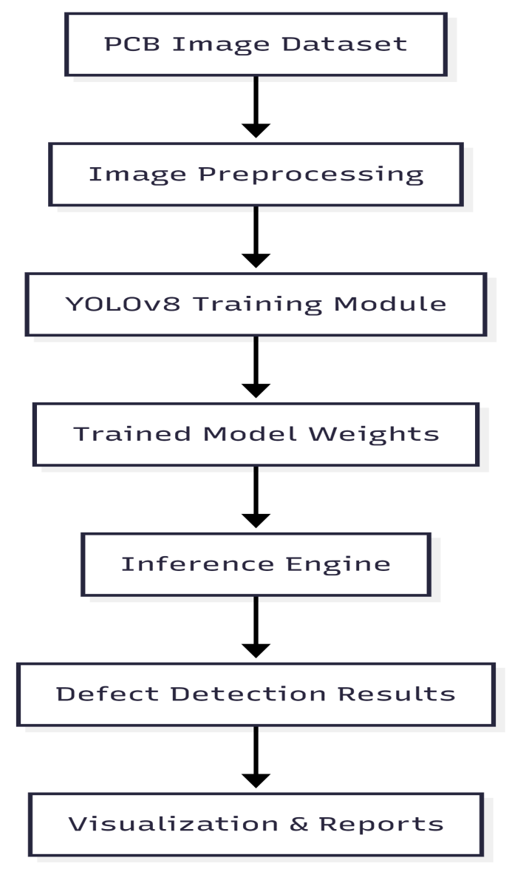

2. System Components Design

2.1 Dataset Preparation Module

Responsibilities:
- Image resizing and normalization
- Annotation conversion to YOLO format
- Dataset splitting (Train / Validation / Test)

Inputs: Raw PCB images, annotation files
Outputs: Structured YOLOv8-compatible dataset

2.2 Model Training Module

Responsibilities:

- Load dataset
- Configure YOLOv8 architecture
- Train model using PyTorch
- Save trained weights

Key Functions:

- load_dataset()
- train_model()
- validate_model()
- save_weights()
2.3 Inference (Defect Detection) Module

Responsibilities:
- Load trained model
- Accept unseen PCB images
- Detect defects
- Generate bounding boxes with confidence scores

Supported Defects:

- Open circuit
- Short circuit
- Missing hole
- Mouse bite
- Spur
- Copper defect

2.4 Evaluation & Reporting Module
Responsibilities:
- Compute mAP, precision, recall, F1-score
- Generate confusion matrix
- Visualize performance graphs

- UML Diagrams

3.1 Use Case Diagram

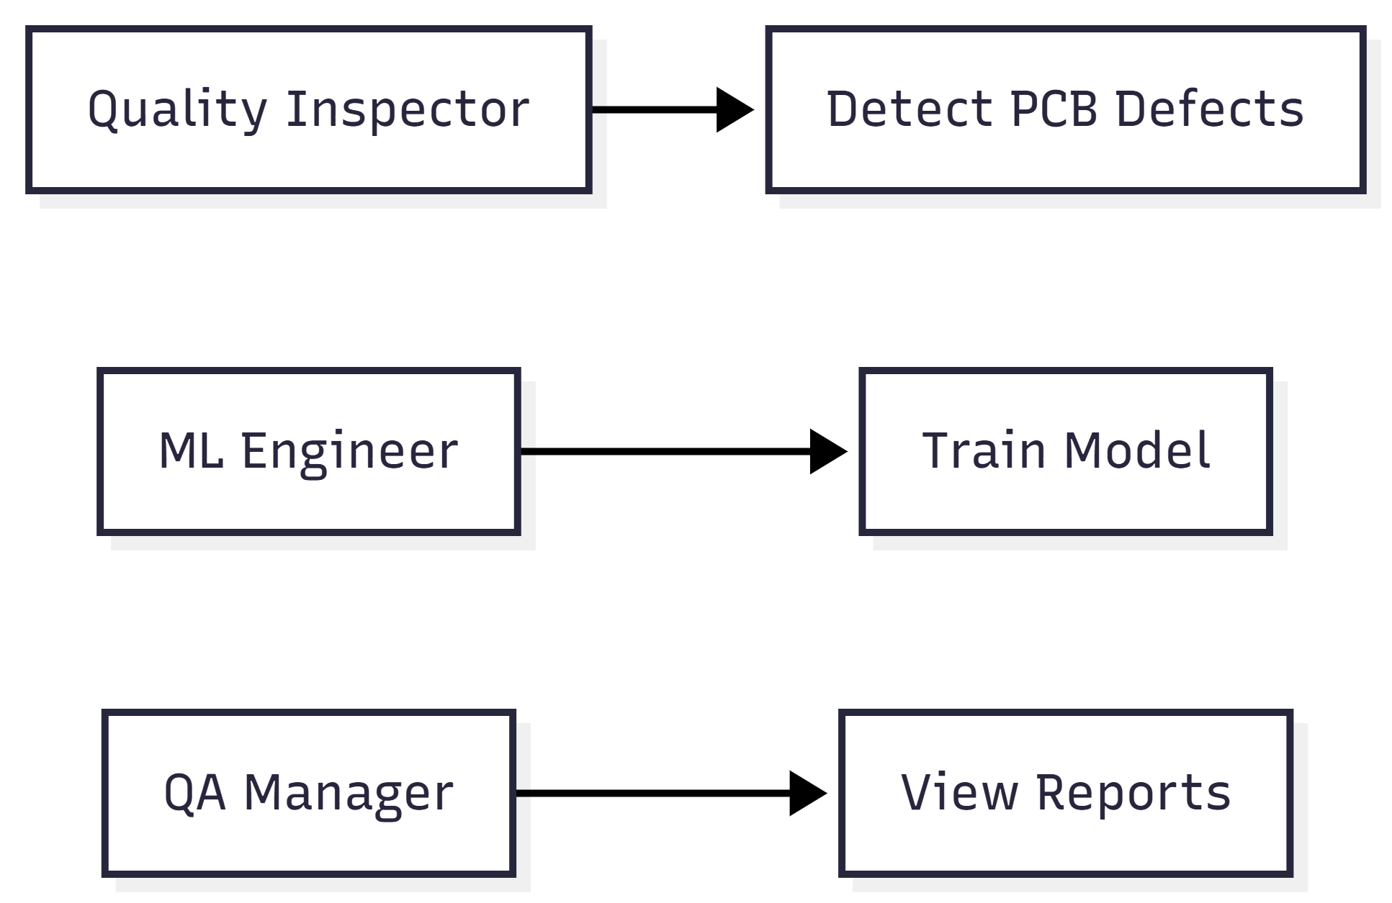

3.2 Sequence Diagram – PCB Defect Detection
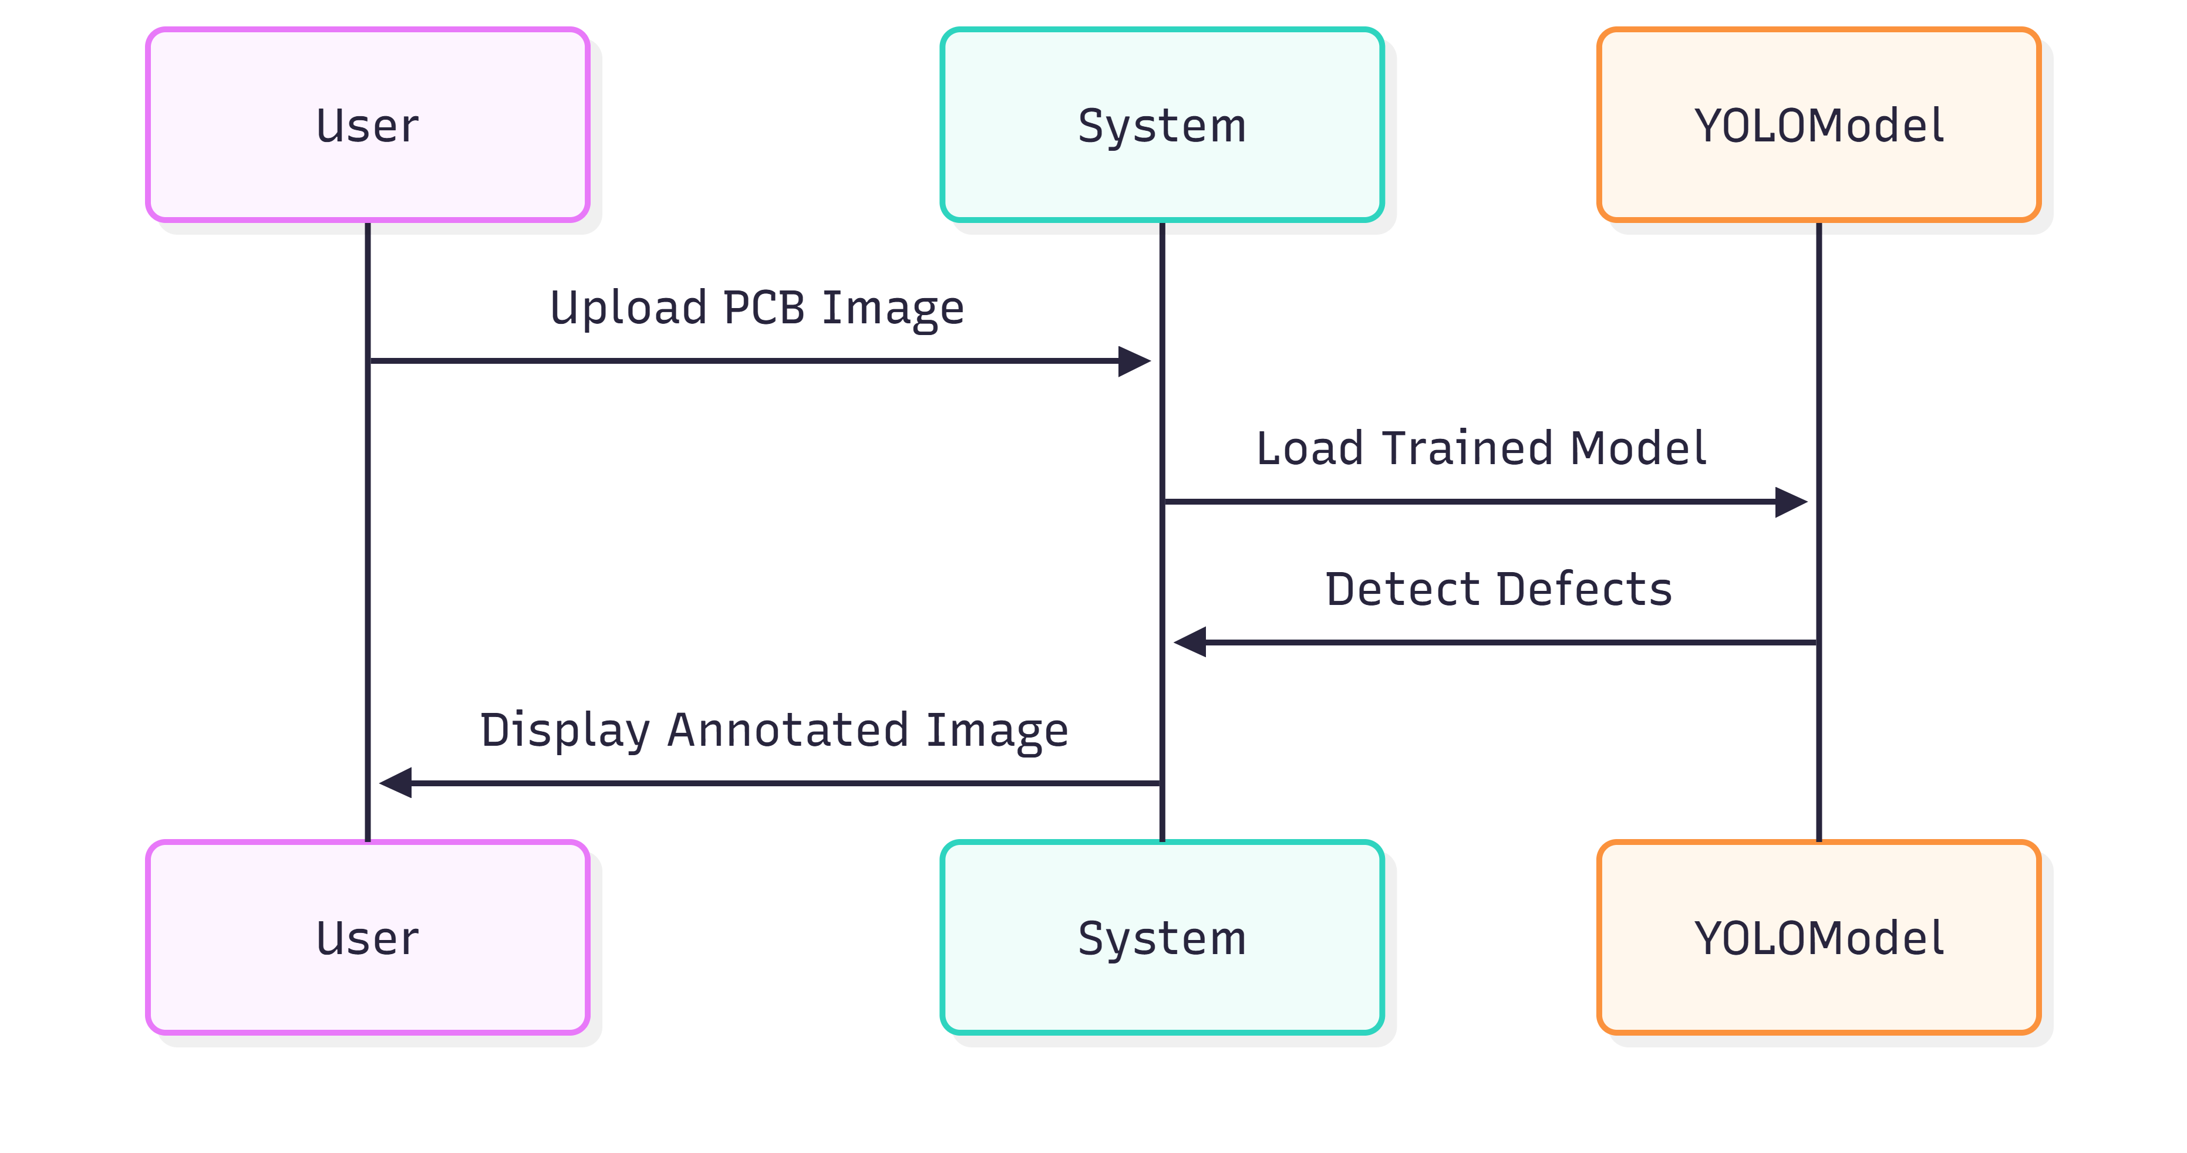

3.3 Class Diagram

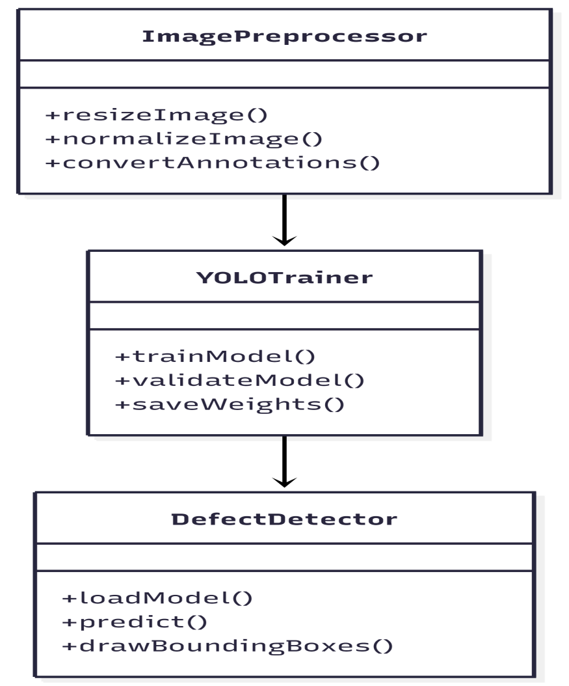

- Data Model Schema

4.1 Conceptual Data Model
Although the system is not database-intensive, it uses structured datasets and metadata files.
Entities:
- Image
Image_ID
File_Path
Resolution
- Annotation
Annotation_ID
Defect_Type
Bounding_Box
- Prediction
Confidence_Score
Predicted_Class

4.2 ER Diagram
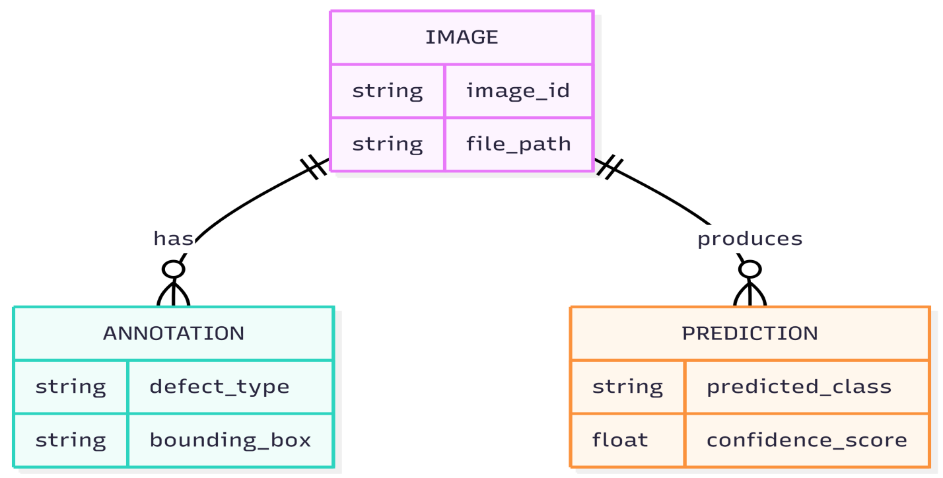
- User Interface Design

5.1 Design Philosophy
- Simple and minimal interface
- High-contrast bounding boxes
- Clear labels and confidence values
- Suitable for non-technical users

5.2 Screens Description
1. Image Upload Screen
- Upload PCB image(s)
- Supported formats: JPG, PNG
2. Detection Results Screen
- Display annotated PCB image
- Show defect type and confidence
3. Evaluation Dashboard
- mAP, Precision, Recall charts
- Confusion matrix visualization

6. External Libraries & APIs
Library | Purpose
PyTorch | Deep learning framework
YOLOv8 (Ultralytics) | Object detection model
OpenCV | Image processing
NumPy | Numerical operations
Matplotlib | Visualization
Pandas | Data handling

7. Coding Conventions & Design Constraints
Coding Conventions
- Python PEP-8 standards
- Modular function-based design
- Meaningful variable and function names
- Inline comments for clarity
Design Constraints
- GPU recommended for training
- Python 3.8+
- Limited to single-layer PCB images (current scope)

